Name _______________________

**The Hemispheres of the Brain**

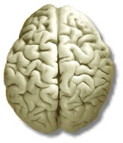

1. ______________________ 2._______________________

**Four Lobes of the Brain**

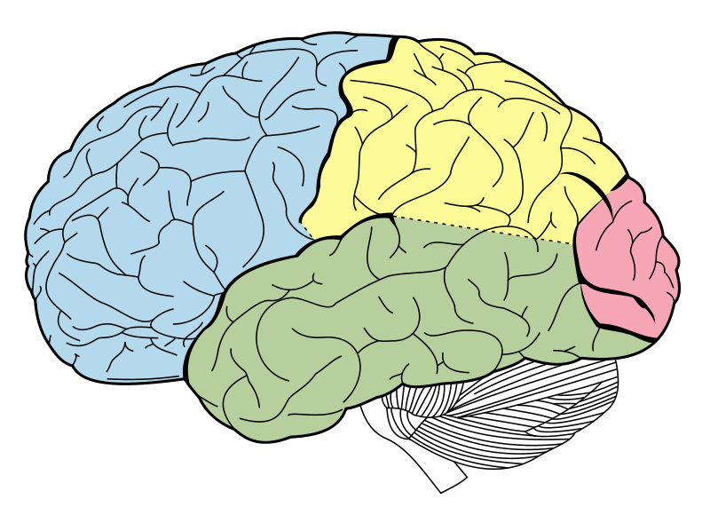

4. ____________________

3. _______________

5. _______________

6. _______________________

**The Interior Brain (IGNORE THE LINES!!!)**

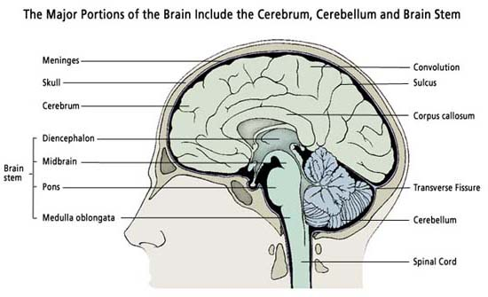

**1.**

**2.**

**3.**

**4.**

**5.**

**6.**

**7.**

**The Limbic System**

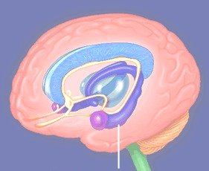

**1 2 3**

**The Nervous System**

**On the figure label the central nervous system and the peripheral nervous system. Then label the parts of the neuron below. Be sure to explain which part of the neuron receives information and which part sends information.**

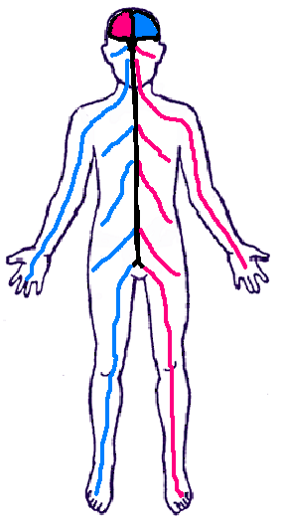

1. __________________________
2. __________________________
3. __________________________
4. __________________________
5. __________________________

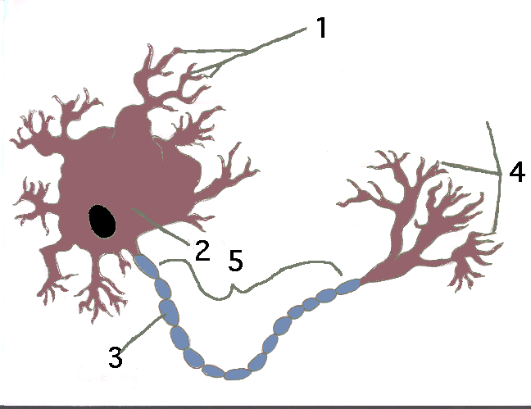

**The Endocrine System**

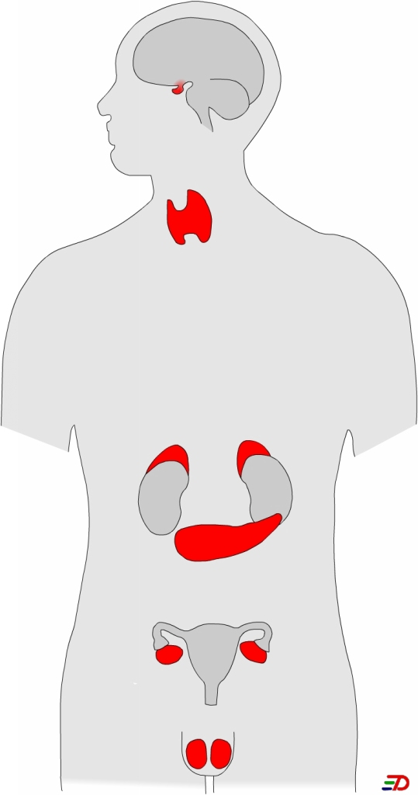

**7.**

**1.**

**2.**

**8.**

**3.**

**4.**

**5.**

**6.**